**High-Level Design Document**

Employee Training Management System

Contents

1 Project Overview 2

1.1.1 Brief introduction of the project. 2

1.1.2 Purpose of the project. 2

1.1.3 Goals of the project: 2

2 Project Scope 2

2.1.1 Key features and functionalities of the mobile app. 2

3 Architecture and Technology Stack 3

3.1.1 Overall architecture of the web app. 3

3.1.2 Technology stack (e.g., programming languages, frameworks, libraries). 3

3.1.3 Rationale behind the chosen technology stack. 4

4 User Interface Design 6

4.1.1 User interface (UI) design approach. 6

5 Web App Components 7

5.1.1 Main Components of the web app 7

5.1.2 Purpose of each component 7

6 Work with Data 8

6.1.1 Approach for the Data Engineering 8

6.1.2 Data Model 8

6.1.3 Data Lineage 9

6.1.4 Approach for the Machine Learning 9

7 Project Resources 10

7.1.1 Roles and responsibilities of the project team members 10

# Project Overview

### Brief introduction of the project.

Our project aims to develop a Web Application Platform that Provide the functionalities to convenient manage the employee training management system. This platform will provide a responsive and user-friendly experience for admin and user enabling them to conveniently track their functionalities.

### Purpose of the project.

The purpose of this project is to empower organisation and enhance their experience by providing them with a comprehensive instrument tracking solution.

The key goals of the project include:

* Enhancing Organisation Experience: By providing a user-friendly and intuitive interface, the platform aims to empower Admin in managing their training journey. User will have convenient access to real-time information about their training plan, module dates, and assessment history, leading to a more engaging and personalized experience.
* Improving User Engagement: Through personalized dashboards, User will have access to essential information about their assessments score and report history, enabling them to make analyse regarding their Training performance.

### Goals of the project:

* Design of the UI/UX components for Employee training management system supporting both user and admin functionality.
* The exact scope of work for the Development Phase will be determined by the Requirements Analysis Phase. By the end of development phase, a Minimum Viable Product (MVP) – as scoped in the Requirements phase.
* Design of the Core application tier including:
  + Front End tier for the ETMS, accessed via a Browser.

# Project Scope

### Key features and functionalities of the mobile app.

**User Authentication:**

User-friendly authentication process for User to their accounts.

Secure authentication mechanisms, including email/password

**Personalized User Dashboard**:

Customized dashboard for each user, displaying relevant information such as Plan information, module information, and assessment score and personalize report.

**Responsive Design:**

User-friendly design to support various devices, including Laptops, Smartphone.

Responsive user interface for optimal viewing and usability across different screen sizes

**Admin Functionalities:**

Admin dashboard for keeping track of all the user.

Functionalities for user creation, adding training category /training plan/ training module adding assessment score and personalize report for the performance.

# Architecture and Technology Stack

### Overall architecture of the web app.

The Web Application Platform for user and admin follows a robust and scalable architecture to ensure optimal performance, security, and usability. The architecture consists of the following components:

**Client-Side Interface:**

The client-side interface forms the user-facing component of the web application. It provides an intuitive and responsive user interface, allowing user to access their personalized dashboards, track training and receive reports.

**Application Logic Layer:**

The application logic layer serves as the backbone of the web application, encompassing the core business logic and functionality. It handles the processing of user requests, orchestrates data retrieval and storage, and performs necessary calculations and validations.

### Technology stack (e.g., programming languages, frameworks, libraries).

**Technology Stack for the Web Application Platform:**

The technology stack for the Web Application Platform for Employee Training Management System will include the following components:

**React**:

React is a popular JavaScript library for building user interfaces, especially for web application. It allows developers to create large web applications that can change data, without reloading the page.

**JavaScript:**

JavaScript is a high-level, interpreted programming language that is primarily used to create interactive effects withing web browsers. It is mainly used for client-side scripting, meaning it runs in the user’s web browsers and can interact with the Document Object Model of the web page, allowing for dynamic content and interactivity.

**React-Router-Dom:**

React-Router-Dom is a popular library for routing in React application. It provides a way to navigate between different components or pages in React application.

**React Navigation:**

React Navigation is a navigation library for React Native applications. It provides a flexible and customizable solution for handling navigation between screens, including stack navigation, tab navigation, and drawer navigation.

**Axios:**

Axios is a widely used JavaScript library for making HTTP requests from the application to the server. It simplifies the process of sending and receiving data, handling API calls, and managing network requests in the mobile app.

**Express:**

Express is a minimal and flexible Node.js web application framework that provides a robust set of features for building web application. It is designed to make the process of building web applications in Node.js much simpler and faster.

**MySQL:**

MySQL is a popular open-source relational database management system that is widely used for web applications. It is known for its reliability, scalability, and ease of use.

**Nodemailer:**

Nodemailer is a popular Node.js module that allows you to send emails from your Node.js applications.It provides an easy-to-use API for sending emails using SMTP,SES and other email sending services.

**Bcrypt:**

Bcrypt is a popular library used for hashing password in Node.js. It provides a way to securely store passwords by hashing them before storing them in a database.

**Nodemon:**

Nodemon is a utility for Node.js that automatically restarts your Node.js application whenever changes are detected in your source code.

**Mysql2:**

Mysql2 is a fast, pure Javascript, mysql driver for Node.js. It is a modernized form of the original mysql driver and offers several improvements and new features. It is widely used in Node.js application for interacting with MySQL databases.

**CORS:**

CORS stands for cross-origin Resource Sharing. It is a mechanism that allows web servers to specify which origins(domains) are allowed to access the resources on the server.

**Snowflake:**

Snowflake is a cloud-based data warehousing company that offers a data platform designed to handle large volumes of data for analytics and business intelligence purposes. It provides a fully managed service with features like data storage, processing, and analytics.

**dbt:**

dbt, short for "Data Build Tool," is an open-source tool that enables data analysts and engineers to transform data in their data warehouse. It follows a "transformation-as-code" approach, allowing users to write SQL queries to transform raw data into analytics-ready tables.

**Python:**

Python is a versatile and popular programming language widely used in machine learning (ML) and artificial intelligence (AI) applications due to its simplicity, readability, and extensive ecosystem of libraries and frameworks.

### Rationale behind the chosen technology stack.

In developing the Web Application Platform for Employee training management system, we have chosen React for Frontend and Express and MySQL for backend as the primary technology stack. The rationale behind this selection is based on the following considerations:

**Virtual DOM:**

React uses a virtual DOM to improve performance by minimizing the number of DOM manipulations, which can lead to faster rendering of UI changes.

**Rich Ecosystem:**

React has a rich ecosystem of libraries and tool (such as React Router for routing and Redux for state management) that can help you build complex frontend applications. Express.js is a popular framework for Node.js, which is known for its performance and scalability. Using Express.js allows you to leverage the Noe.js ecosystem and its many libraries and modules.

**Middleware Support:**

Express.js has a robust middleware system that allows you to add functionality to your application, such as authentication, logging, and error handling with ease.

**Performance:**

When configured properly, Express.js and MySQL can provide good performance for web applications, making it easy to interact with MySQL database in your application.

**Large Developer Community and Ecosystem:**

React with Express and MySQL boasts a vast and active developer community. This thriving community provides extensive support, resources, and libraries that accelerate development and problem-solving. The availability of a wide range of open-source libraries and components allows us to leverage existing solutions and integrate additional functionalities efficiently.

**Code Reusability:**

React component-based architecture promotes code reusability. By developing reusable components, we can efficiently manage the application's UI elements and logic across different pages. This approach not only simplifies development but also facilitates maintenance and future updates, as changes made to shared components propagate throughout the application.

**Flexibility and Customizability:**

React allows you to customize components and UI elements extensively, giving you the flexibility to create unique user experiences. Express.js provides robust error-handling mechanisms, allowing you to customize error responses and behaviour based on your application’s needs.

Based on these considerations, React, Express and MySQL emerges as the optimal technology stack for developing the web Application. It enables us to deliver a high-quality, code reusability, and a vibrant developer community, while ensuring time and cost efficiency in the development process.

# User Interface Design

### User interface (UI) design approach.

|  |  |
| --- | --- |
| **Login Screen:** |  |
|  |  |

**Admin Screen:**

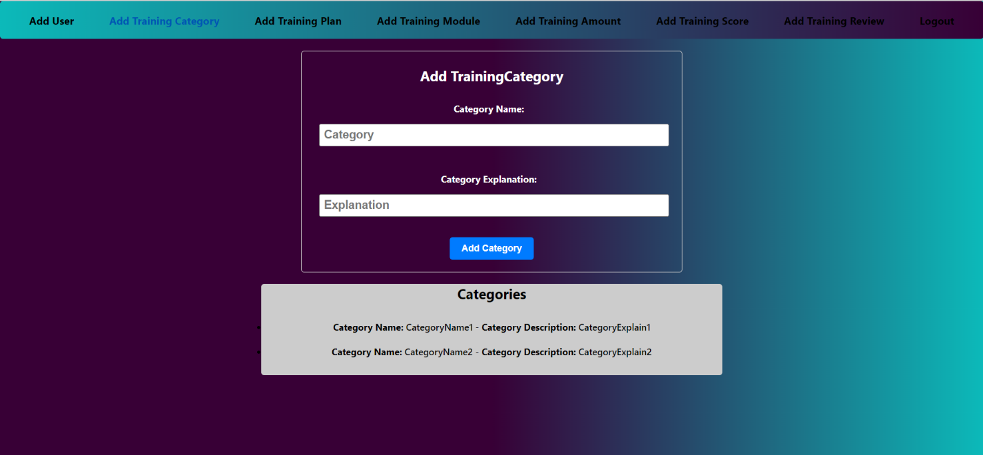

**User screen:**

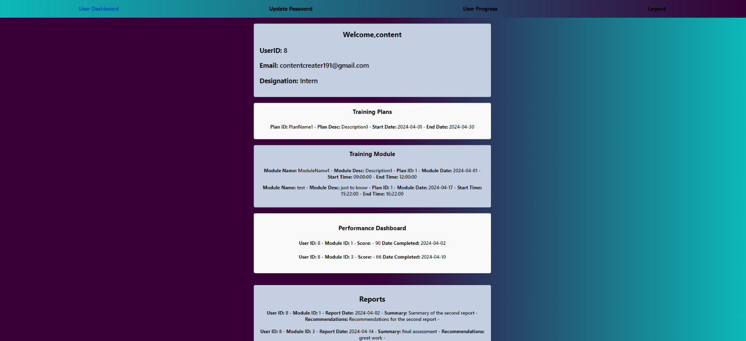

# Web App Components

Testing and quality assurance are essential processes in software development that aim to ensure the reliability, functionality, and overall quality of a software product. These processes involve systematically examining and validating the software at various stages to identify defects, bugs, and any deviations from the expected behaviour. By conducting thorough testing and quality assurance, developers can uncover and rectify issues early in the development cycle, enhancing user satisfaction, minimizing risks, and ultimately delivering a stable and dependable software product to the end users.

### Main Components of the web app

* Admin Dashboard
* Login
* User Dashboard
* User Creation
* Category Creation
* Plan Creation
* Module Creation
* Assessment Score
* Module Amount
* Assessment Report
* Update Password
* User Progress

### Purpose of each component

#### Admin Dashboard

The Admin Dashboard provides navigation links or buttons for administrators to access the following pages: User creation Page, category creation, plan creation, module creation, assessment score, module amount, assessment report These links/buttons enable admins to easily navigate between different sections of the system for creating users and managing events.

#### Login

A login typically refers to a secure entry point or interface within a system, website, or application that grants privileges and access to certain features or data based on who is logging in.

#### User Creation

Admins can create the user and will assign designation to it. And based on that the training will be scheduled. He /She will get a system generated mail for credential and will have to change the password for the first time when user login.

#### Category creation

Admin will be able to add category on which training will be provided.

#### Plan creation

Admin will be able to create a plan and specify then start date and end date for that.

#### Module Creation

Admin will be able to create a module and will specify the date on which specific module will be scheduled and time between which the training will be delivered.

#### Assessment score

Admin will be able to add score based on the performance of a particular user.

#### Module amount

Admin will be able to add amount which will be spend during the module training.

#### Assessment Report

Admin will be able to add personalize feedback based on the performance of the user.

#### Update Password

The feature allows user to change their existing passwords to enhance account security.

#### User progress

User will be able to specify the progress on a particular module.

#### User Dashboard

The User will be able to track all the information related to him on a single page.

# Work with Data

Testing and quality assurance are essential processes in software development that aim to ensure the reliability, functionality, and overall quality of a software product minimizing risks, and ultimately delivering a stable and dependable software product to the end users.

### Approach for the Data Engineering

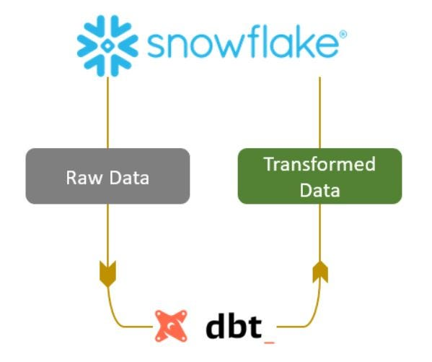

### Data Model

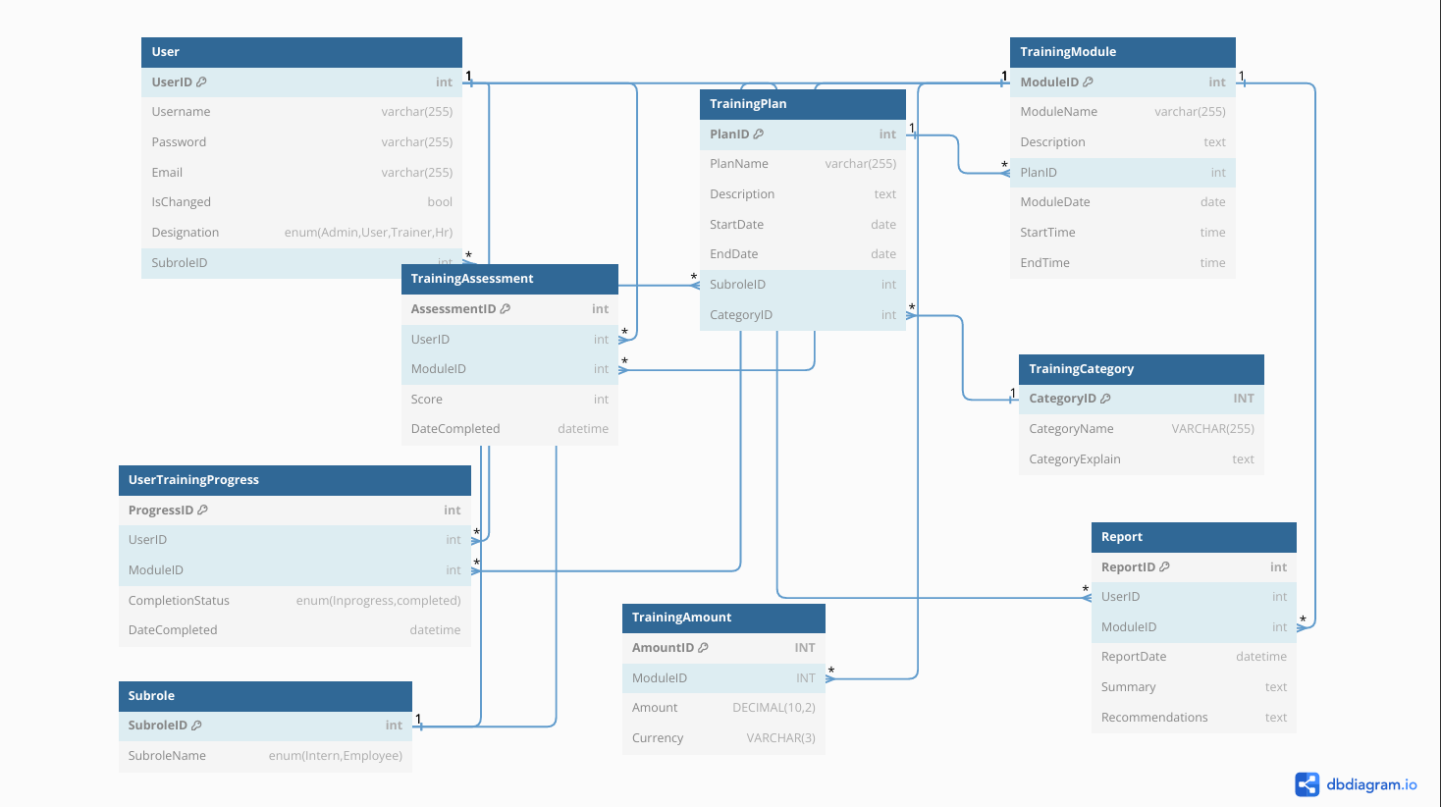

### Data Lineage

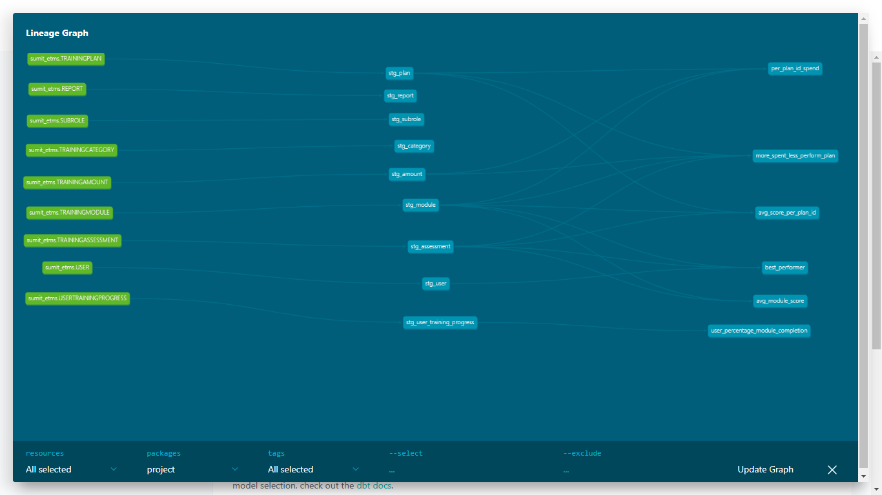

### Approach for the Machine Learning

**Exploratory Data Analysis (EDA):**

Exploratory Data Analysis (EDA) is a crucial initial step in any data analysis or machine learning project. It involves exploring and summarizing the main characteristics of a dataset to understand its underlying structure, patterns, and relationships.

**Feature Extraction:**

Feature extraction is the process of transforming raw data into a set of meaningful features that can be used as input for machine learning algorithms.

**Model Development:**

Model development is the process of building and training machine learning models using the preprocessed data obtained from exploratory data analysis and feature extraction. The ultimate goal of model development is to create predictive models that can make accurate and reliable predictions on unseen data, thereby solving real-world problems and generating actionable insights. Using cosine similarity to build a recommendation system is a common approach, especially in content-based recommendation systems.

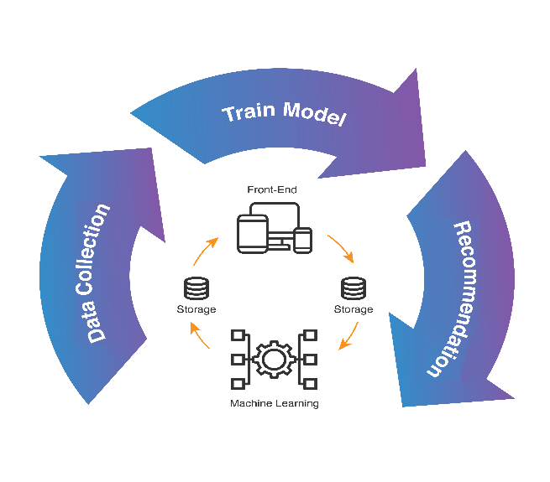

# Project Resources

### Roles and responsibilities of the project team members

Sumit Kumar – Involved in developing the full stack application, data engineering and data science.

**Appendix Title**

Document Title